GitHub CLI

What is GitHub CLI
# Source: AI Source: Provided by: [Data Path: Persons Table -> ID Column: 1, Name_En Column: Motasem Essam] -> From: [Chatgpt (GPT‑5 Mini)] on [3/6/2026]
GitHub CLI (officially called GitHub CLI) is a command-line tool that lets you interact with GitHub directly from your terminal instead of using the web interface.
Its main command is:
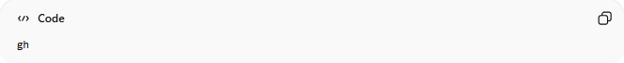
gh

What You Can Do With GitHub CLI
# Source: AI Source: Provided by: [Data Path: Persons Table -> ID Column: 1, Name_En Column: Motasem Essam] -> From: [Chatgpt (GPT‑5 Mini)] on [3/6/2026]
🔹 Manage Repositories
- Create new repositories
- Clone repositories
- Fork repositories
- View repo info
Example:
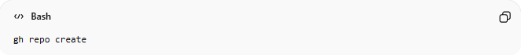
gh repo create

🔹 Work With Pull Requests
# Source: AI Source: Provided by: [Data Path: Persons Table -> ID Column: 1, Name_En Column: Motasem Essam] -> From: [Chatgpt (GPT‑5 Mini)] on [3/6/2026]
- Create pull requests
- Review PRs
- Merge PRs
- Check PR status
Example:
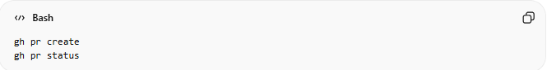
gh pr create
gh pr status

🔹 Handle Issues
# Source: AI Source: Provided by: [Data Path: Persons Table -> ID Column: 1, Name_En Column: Motasem Essam] -> From: [Chatgpt (GPT‑5 Mini)] on [3/6/2026]
- Create issues
- View issues
- Comment on issues
- Close issues
Example:
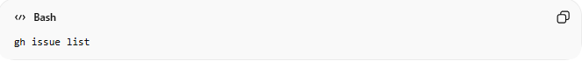
gh issue list

🔹 Manage Workflows (GitHub Actions)
# Source: AI Source: Provided by: [Data Path: Persons Table -> ID Column: 1, Name_En Column: Motasem Essam] -> From: [Chatgpt (GPT‑5 Mini)] on [3/6/2026]
Interact with GitHub Actions:
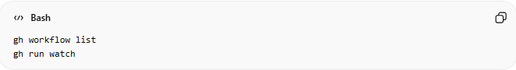
gh workflow list
gh run watch

🔹 Authentication
# Source: AI Source: Provided by: [Data Path: Persons Table -> ID Column: 1, Name_En Column: Motasem Essam] -> From: [Chatgpt (GPT‑5 Mini)] on [3/6/2026]
Log in to your GitHub account securely:
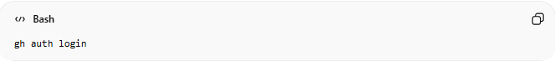
gh auth login

🔹 Refresh GitHub CLI Authentication
# Source: AI Source: Provided by: [Data Path: Persons Table -> ID Column: 1, Name_En Column: Motasem Essam] -> From: [Chatgpt (GPT‑5 Mini)] on [3/6/2026]
Sometimes your GitHub CLI (gh) authentication token may expire or need to be refreshed. You can update or re-authenticate from the terminal.

1️⃣ Check Current Authentication Status
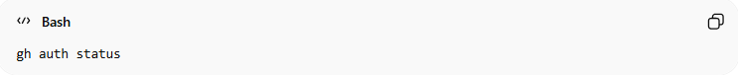
gh auth status
- Shows whether you are currently logged in.
- Displays your GitHub username and authentication method (OAuth, token, or GitHub App).

2️⃣ Log Out (Optional)
If you want to start fresh:
gh auth logout
- Confirms that your token or session will be removed.
- You can choose all accounts or a specific account if multiple are used.

3️⃣ Log In / Refresh Authentication
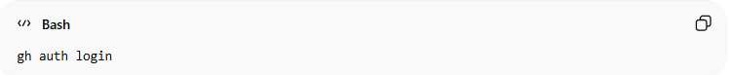
gh auth login
- Follow the prompts:
  - Choose GitHub.com or GitHub Enterprise.
  - Select HTTPS or SSH for Git operations.
  - Choose authentication method: Web browser or Personal Access Token (PAT).
  - Complete authentication to refresh the token.

4️⃣ Verify New Authentication
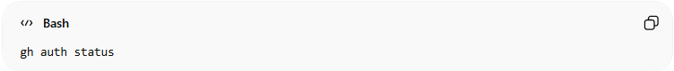
gh auth status
- Confirms that your CLI is authenticated with a valid token.
- Now you can continue running gh commands without errors.

💡 Notes
- Web browser login → easiest for most users.
- Personal Access Token (PAT) → useful for scripts or automation.
- Refreshing ensures you avoid authentication errors when creating PRs, issues, or pushing code.

Why Use GitHub CLI?
# Source: AI Source: Provided by: [Data Path: Persons Table -> ID Column: 1, Name_En Column: Motasem Essam] -> From: [Chatgpt (GPT‑5 Mini)] on [3/6/2026]
- ⚡ Faster than using the browser
- 🧠 Great for developers who live in the terminal
- 🔄 Easy automation and scripting
- 🔗 Works alongside Git commands

Simple Example Workflow
# Source: AI Source: Provided by: [Data Path: Persons Table -> ID Column: 1, Name_En Column: Motasem Essam] -> From: [Chatgpt (GPT‑5 Mini)] on [3/6/2026]
Instead of:
- Push code
- Open browser
- Create pull request manually
You can:
git push
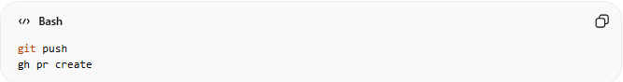
gh pr create

Download GitHub CLI
# Source: ScreenShots Source: Provided by: [Persons Table -> ID Column: 1, Name_En Column: Motasem Essam] -> Tool: [Lightshot Program] -> From [Site: Google Search: All: GitHub CLI] on [3/6/2026]
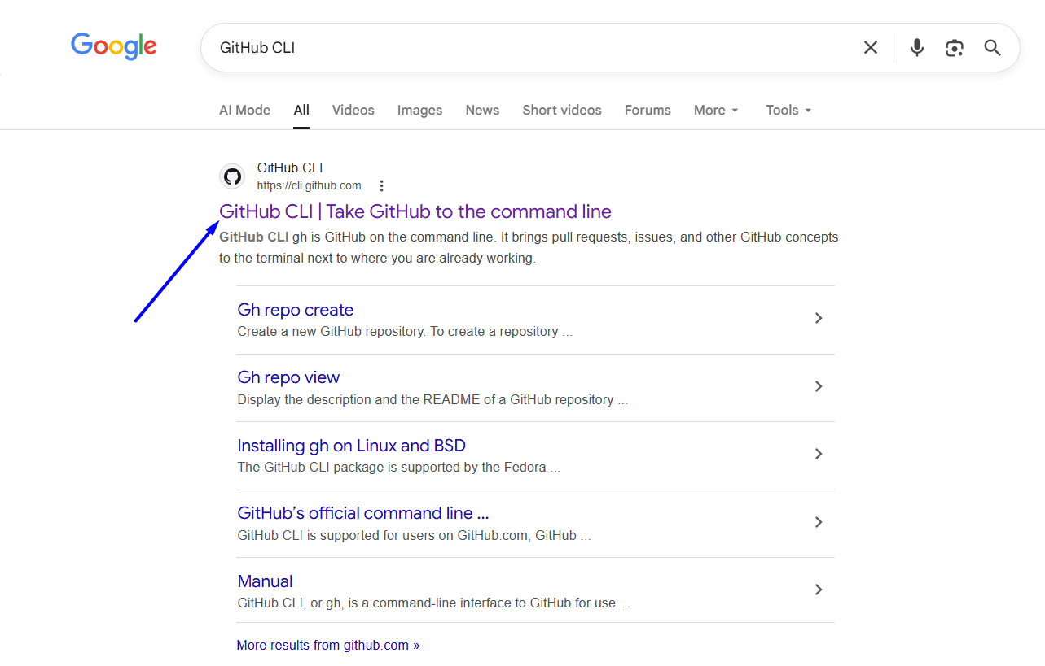
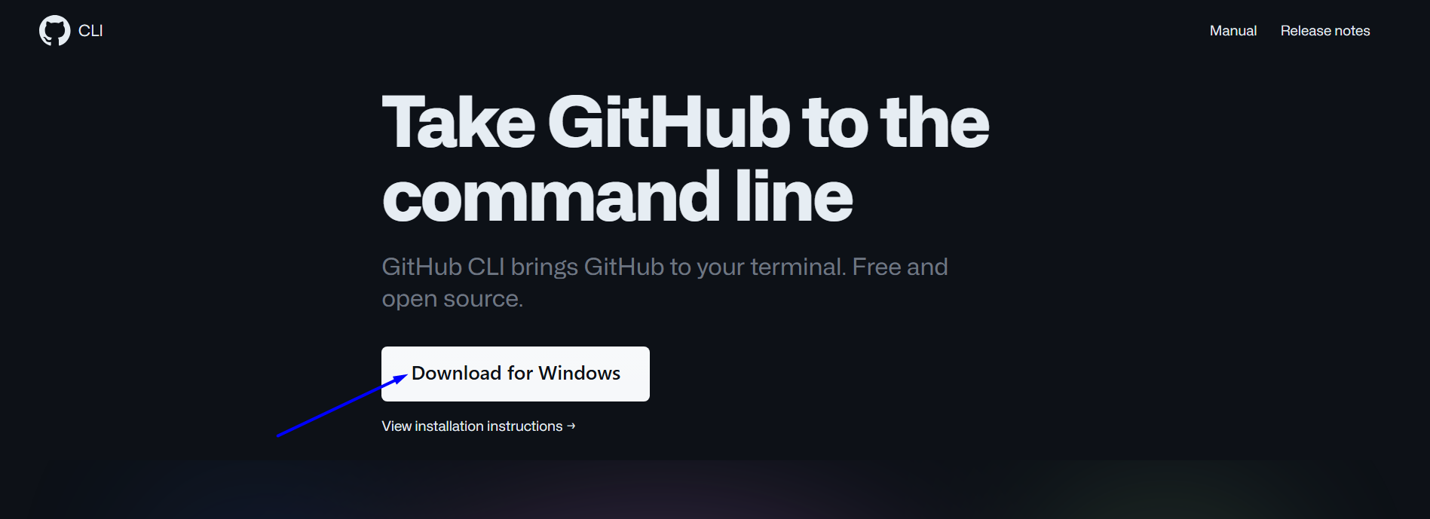
# Source: ScreenShots Source: Provided by: [Persons Table -> ID Column: 1, Name_En Column: Motasem Essam] -> Tool: [Lightshot Program] -> From [Operating System: Windows] on [3/6/2026]
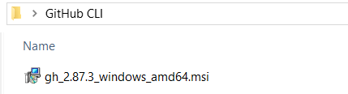

Install GitHub CLI
# Source: ScreenShots Source: Provided by: [Persons Table -> ID Column: 1, Name_En Column: Motasem Essam] -> Tool: [Lightshot Program] -> From [Operating System: Windows] on [3/6/2026]
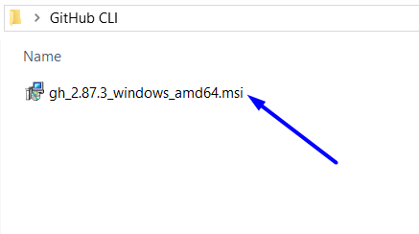
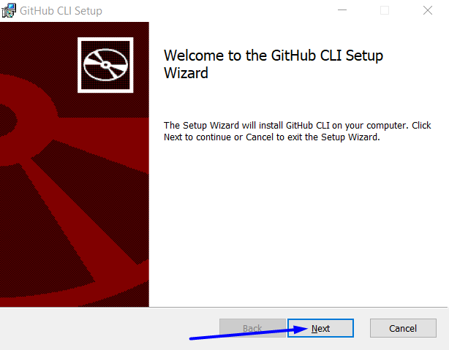
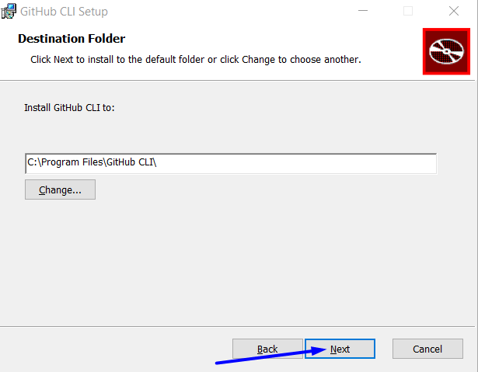
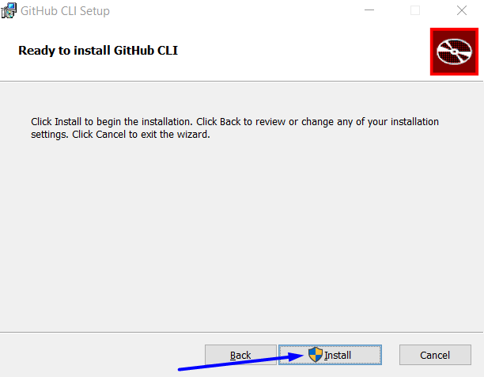
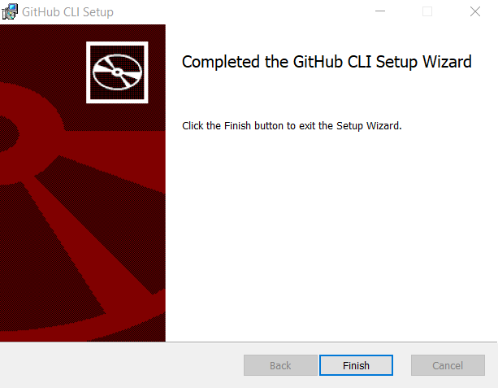

Run GitHub CLI
# Source: ScreenShots Source: Provided by: [Persons Table -> ID Column: 1, Name_En Column: Motasem Essam] -> Tool: [Lightshot Program] -> From [Operating System: Windows] on [3/6/2026]
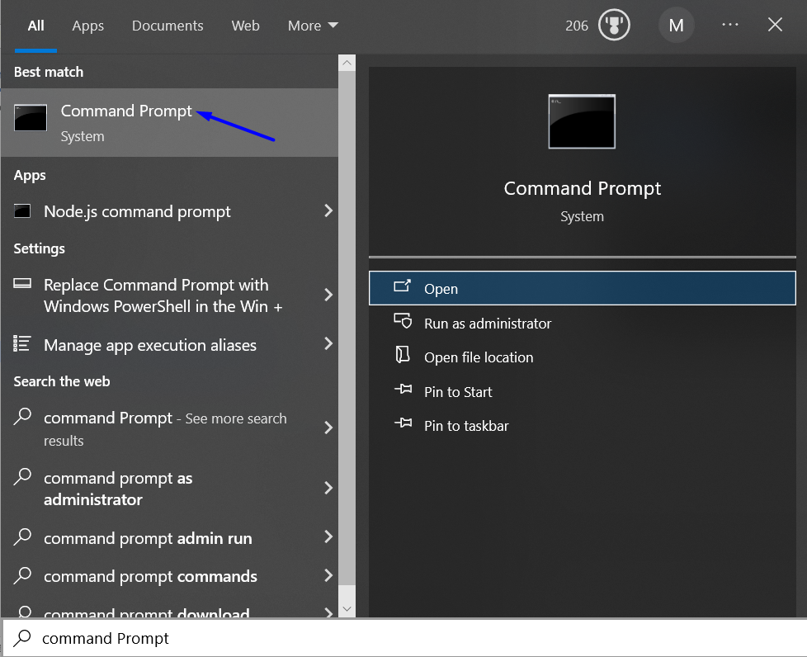
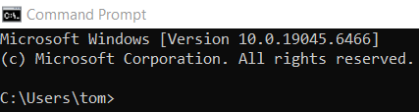
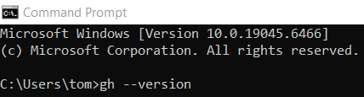
gh --version
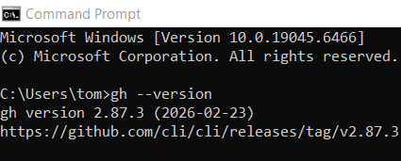

Log In
# Source: ScreenShots Source: Provided by: [Persons Table -> ID Column: 1, Name_En Column: Motasem Essam] -> Tool: [Lightshot Program] -> From [Operating System: Windows] on [3/6/2026]
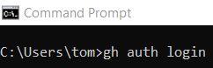
gh auth login
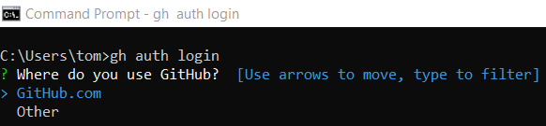
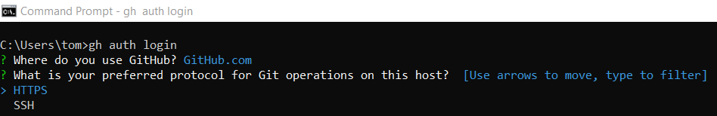
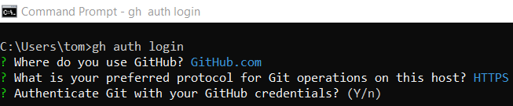
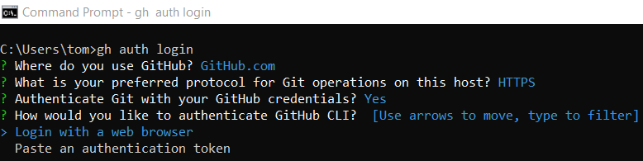
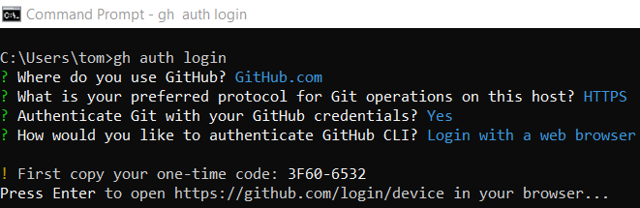
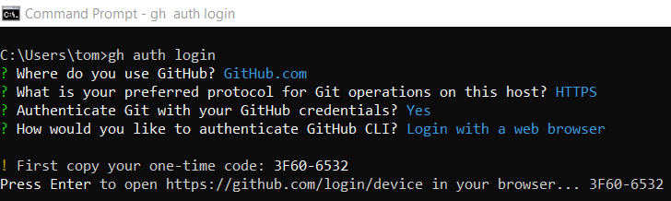
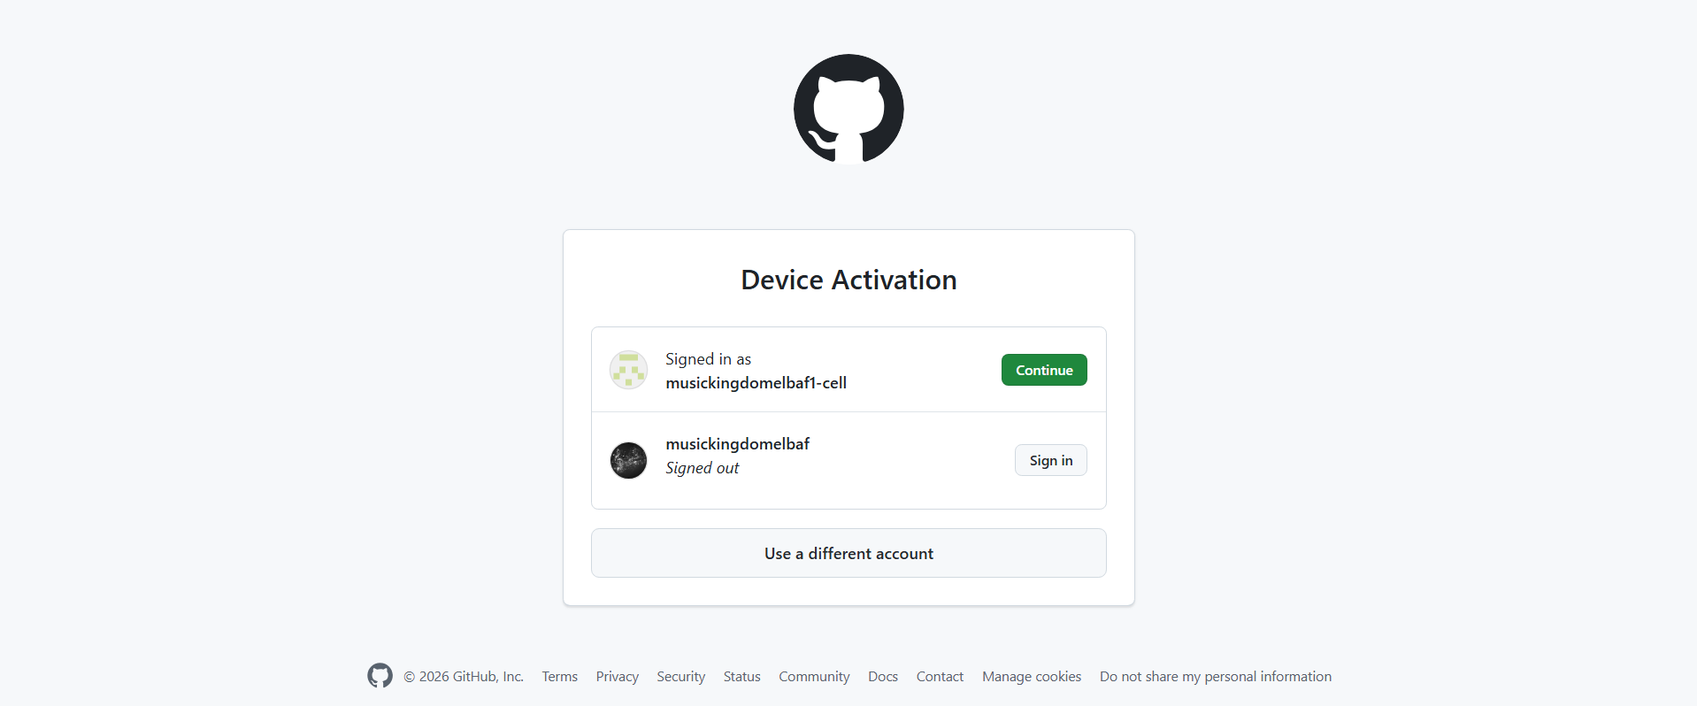
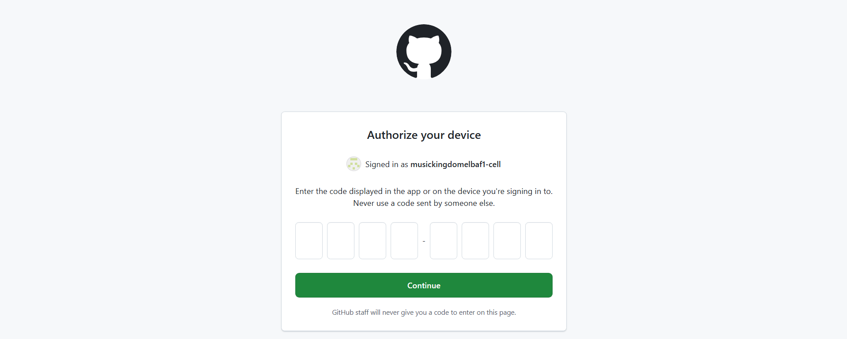
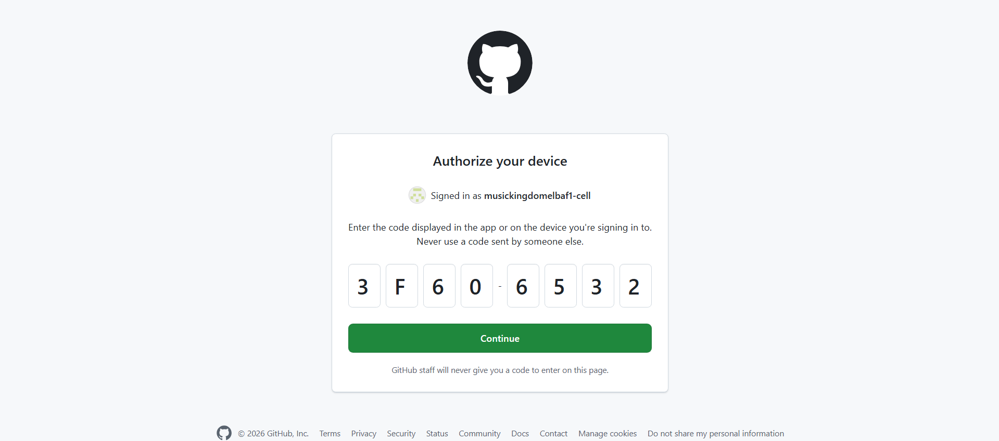
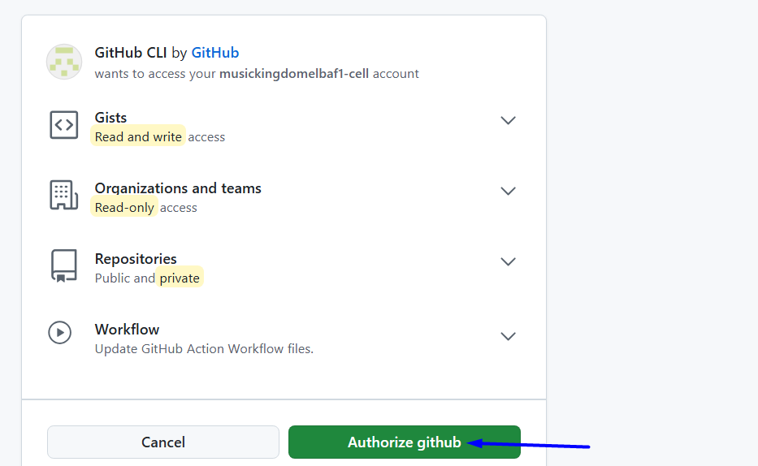
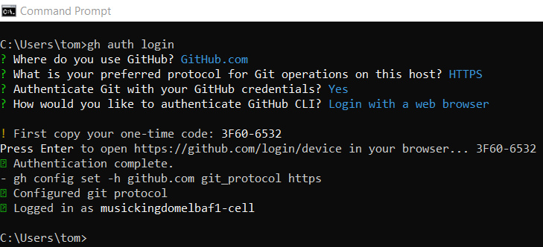

Viewing Your Repositories
# Source: ScreenShots Source: Provided by: [Persons Table -> ID Column: 1, Name_En Column: Motasem Essam] -> Tool: [Lightshot Program] -> From [Operating System: Windows] on [3/6/2026]
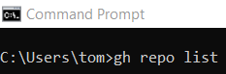
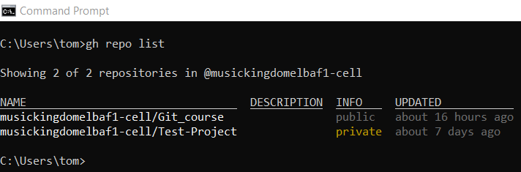

New repository
# Source: ScreenShots Source: Provided by: [Persons Table -> ID Column: 1, Name_En Column: Motasem Essam] -> Tool: [Lightshot Program] -> From [Operating System: Windows] on [3/6/2026]
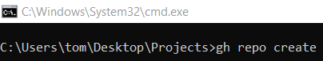
gh repo create
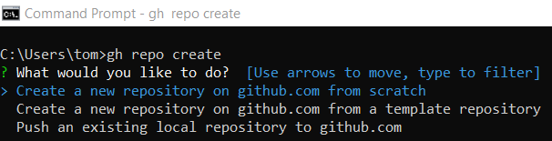
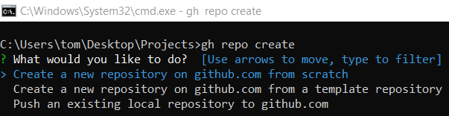

Option 1: Create a new repository on github.com from scratch

Method 1: Create Repository (Interactive – From Scratch)
# Source: ScreenShots Source: Provided by: [Persons Table -> ID Column: 1, Name_En Column: Motasem Essam] -> Tool: [Lightshot Program] -> From [Operating System: Windows] on [3/6/2026]
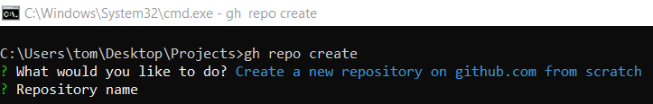
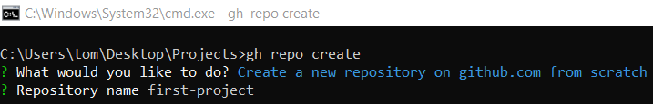
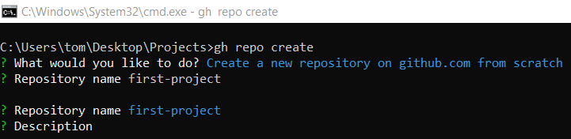
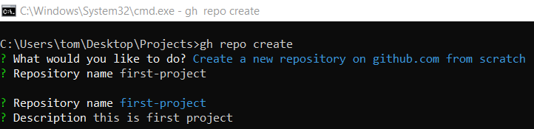
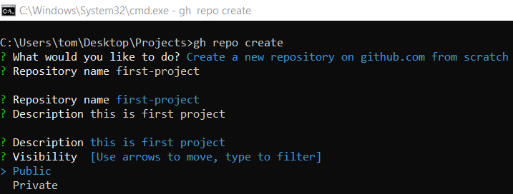
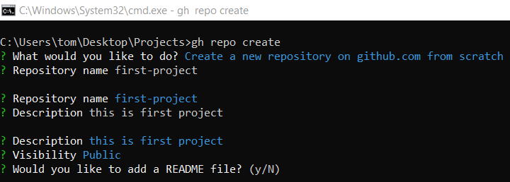
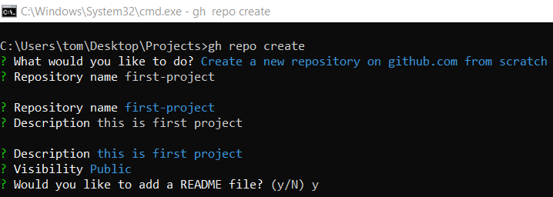
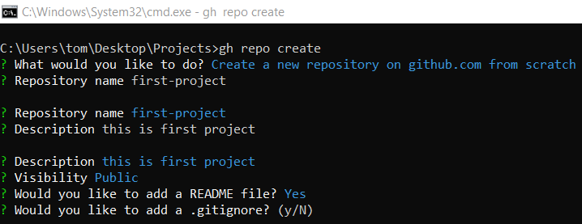
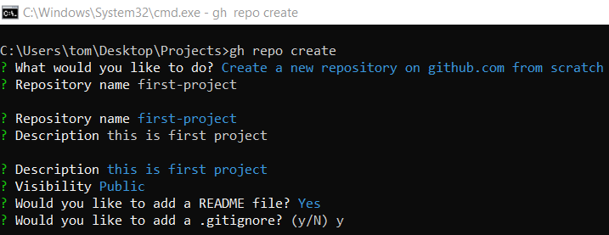
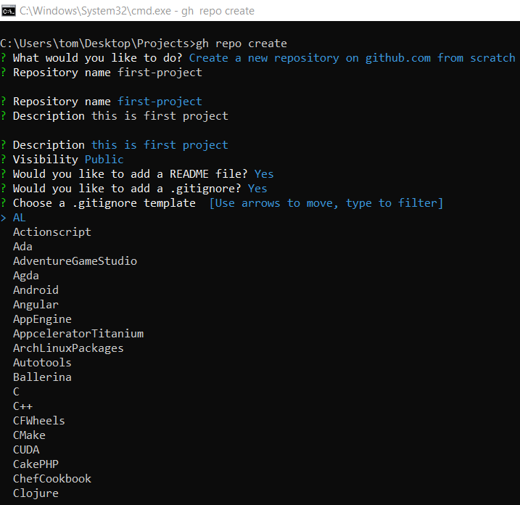
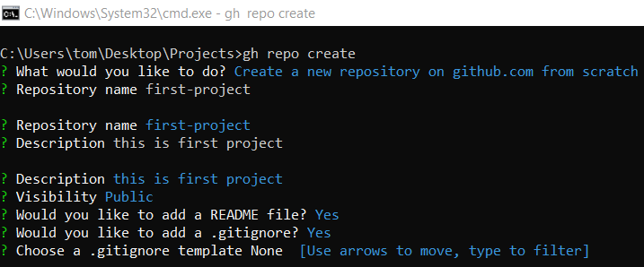
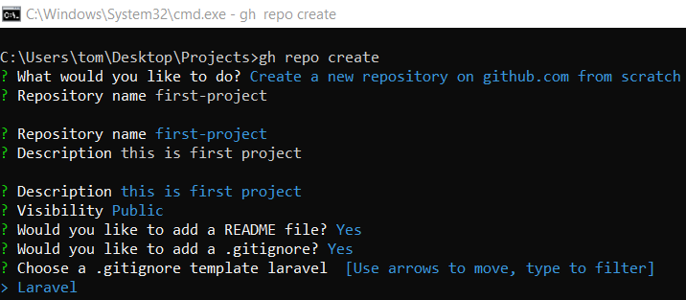
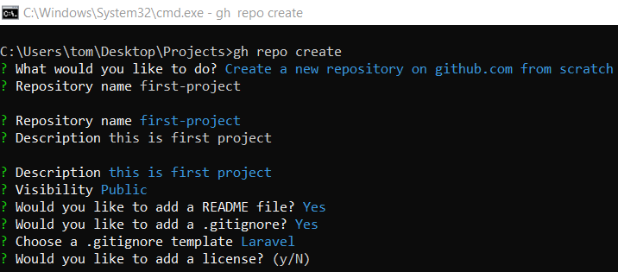
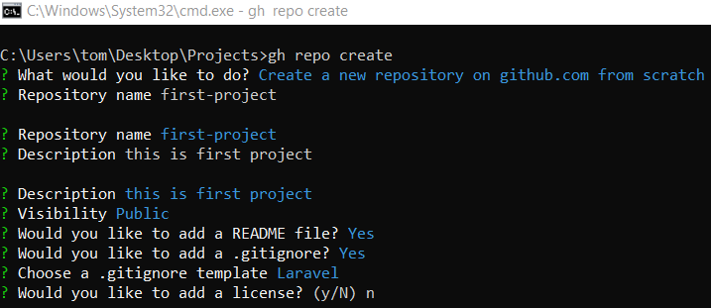
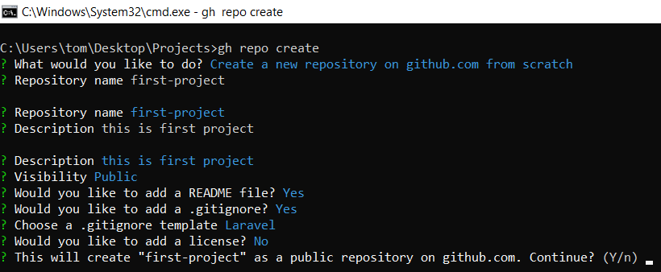
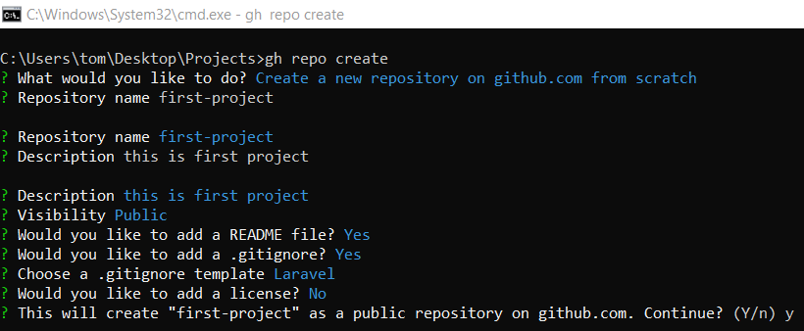
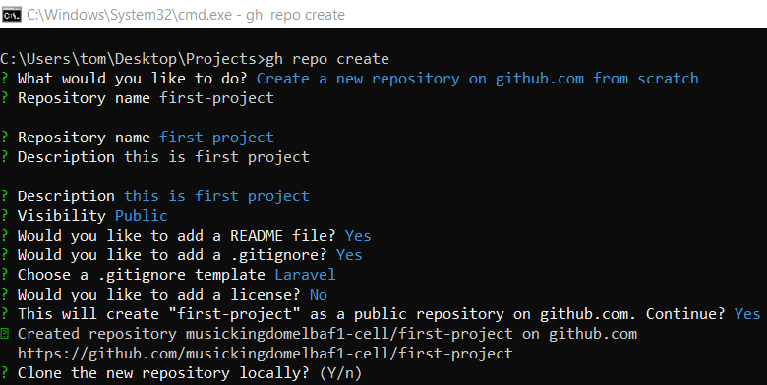
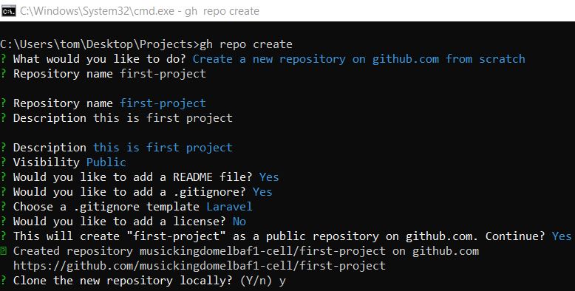
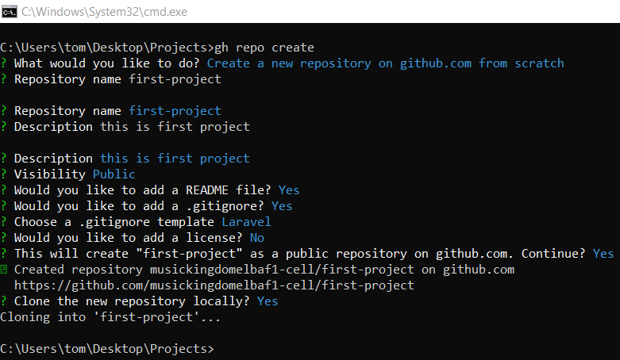
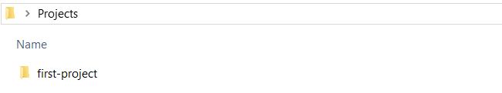
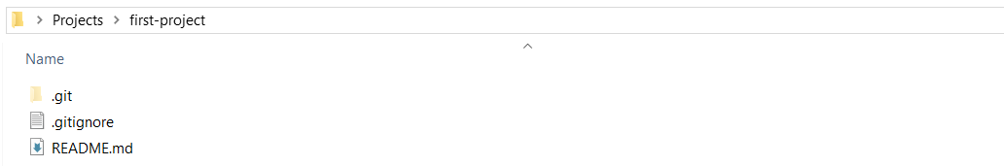

# Source: ScreenShots Source: Provided by: [Persons Table -> ID Column: 1, Name_En Column: Motasem Essam] -> Tool: [Lightshot Program] -> From [Site: https://github.com] on [3/6/2026]
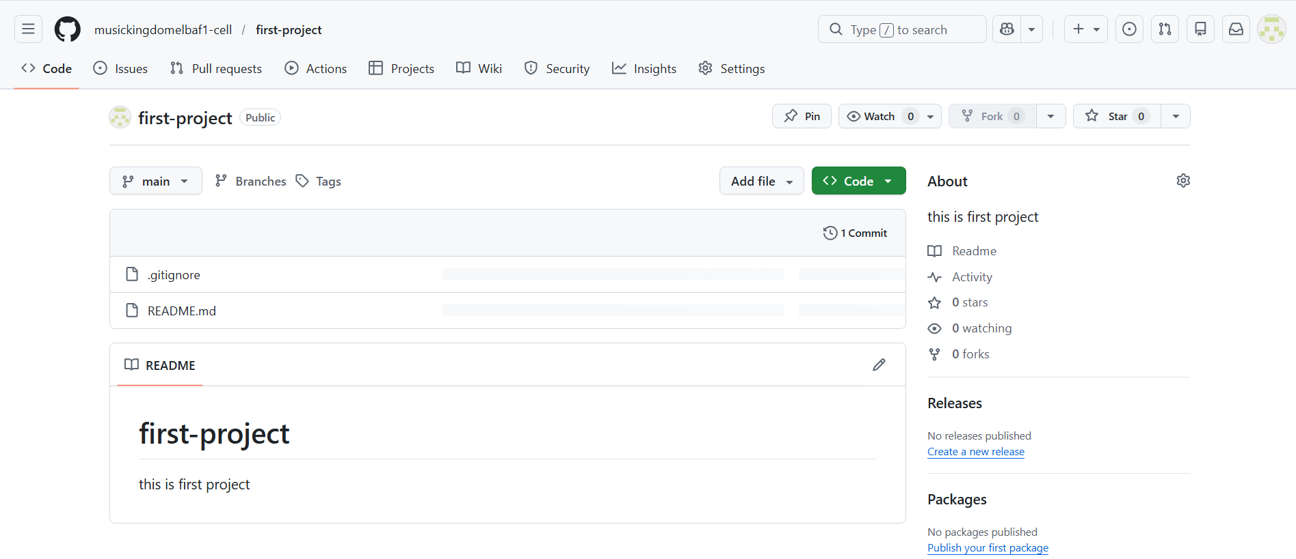

Method 2: Create Repository (Direct Command – From Scratch)
# Source: ScreenShots Source: Provided by: [Persons Table -> ID Column: 1, Name_En Column: Motasem Essam] -> Tool: [Lightshot Program] -> From [Operating System: Windows] on [3/6/2026]
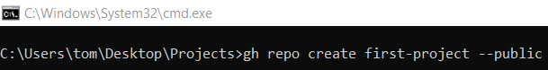
gh repo create first-project --public
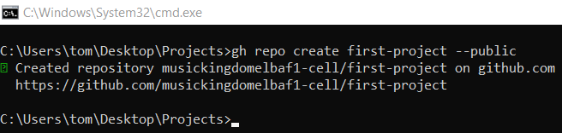

# Source: AI Source: Provided by: [Data Path: Persons Table -> ID Column: 1, Name_En Column: Motasem Essam] -> From: [Chatgpt (GPT‑5 Mini)] on [3/6/2026]
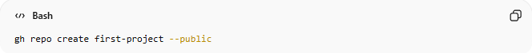
gh repo create first-project –public
- gh → GitHub CLI
- repo → Work with repositories
- create → Create a new repository
- first-project → Repository name
- --public → Make it public
✅ Creates a new public repository called first-project on GitHub.

Option 2: Create a new repository on github.com from a template repository
# Source: ScreenShots Source: Provided by: [Persons Table -> ID Column: 1, Name_En Column: Motasem Essam] -> Tool: [Lightshot Program] -> From [Site: https://github.com] on [3/6/2026]
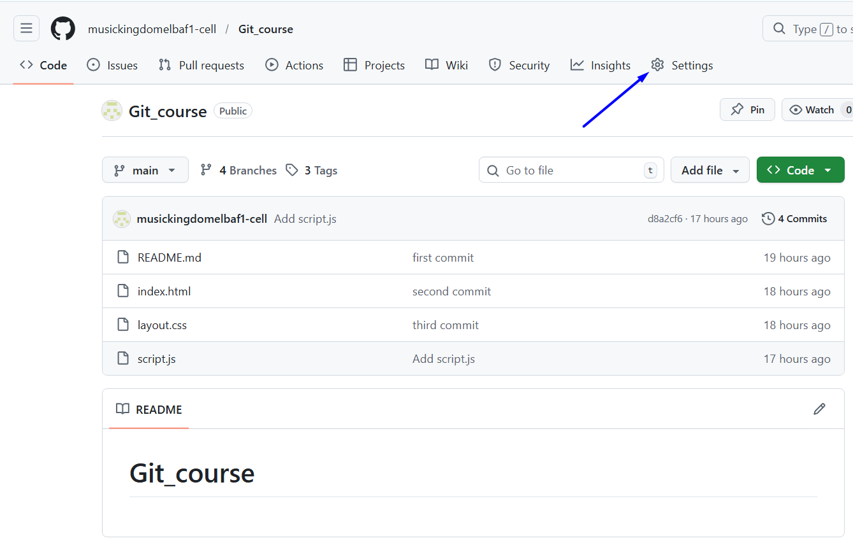
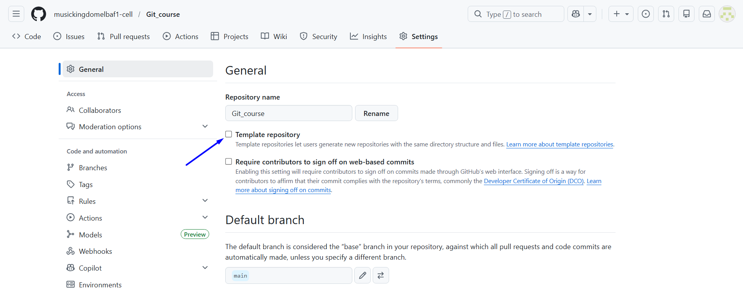
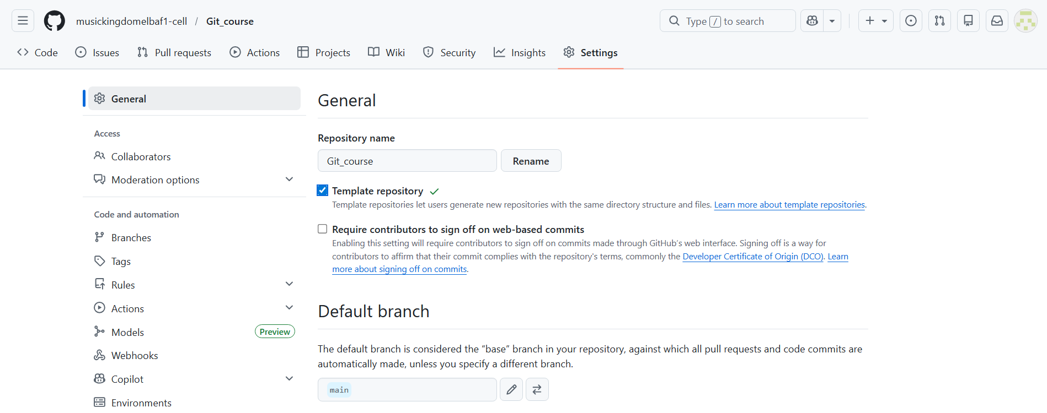
# Source: ScreenShots Source: Provided by: [Persons Table -> ID Column: 1, Name_En Column: Motasem Essam] -> Tool: [Lightshot Program] -> From [Operating System: Windows] on [3/6/2026]
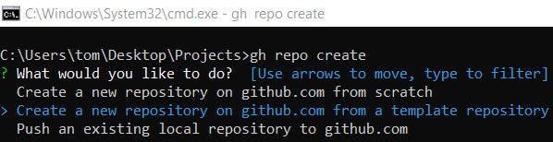
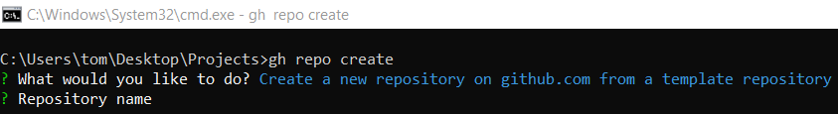
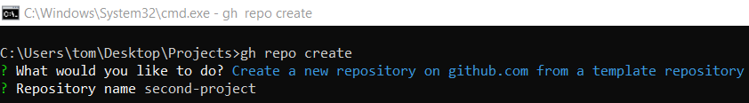
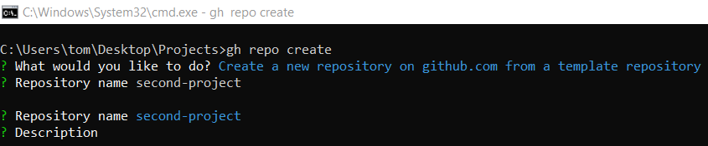
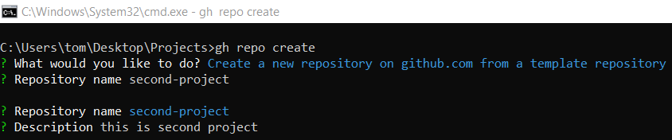
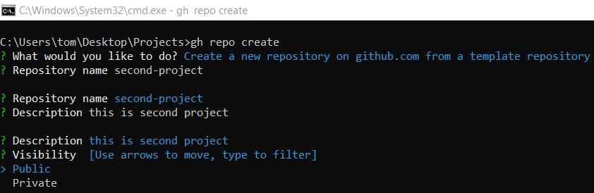
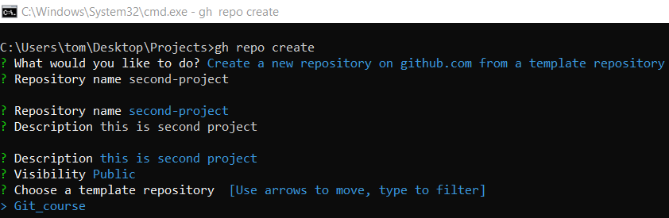
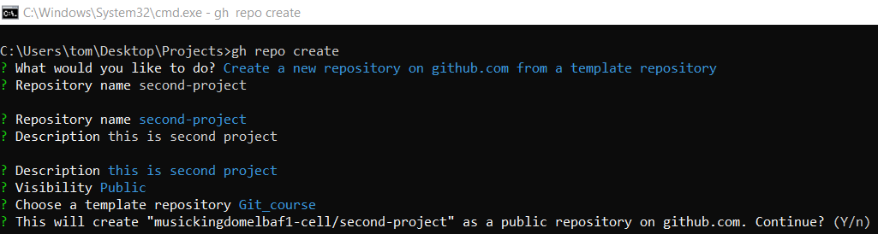
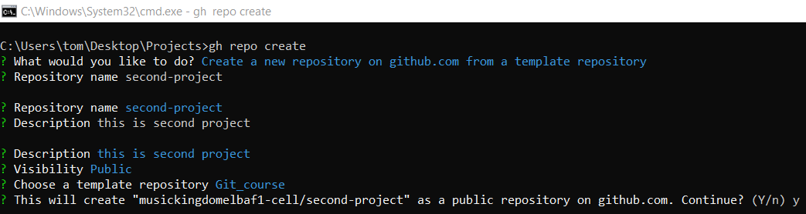
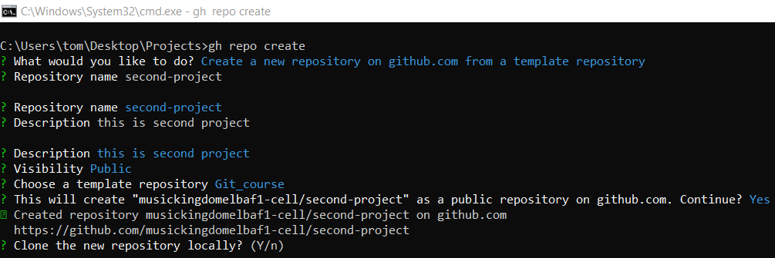
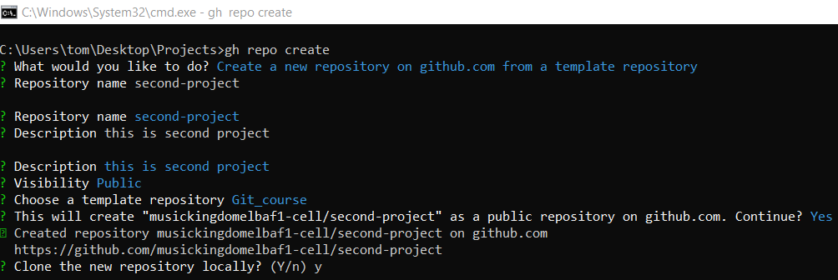
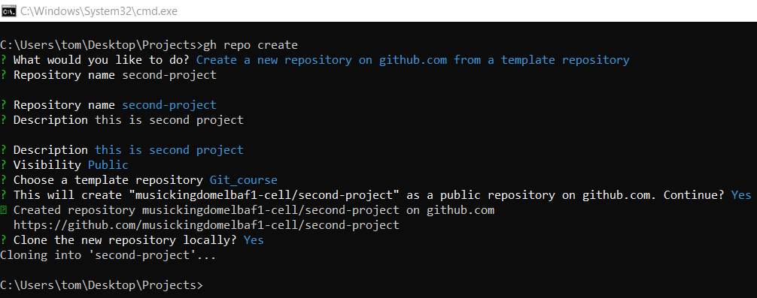
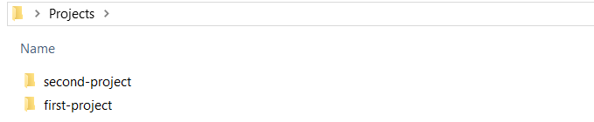
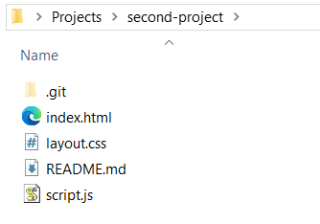

# Source: ScreenShots Source: Provided by: [Persons Table -> ID Column: 1, Name_En Column: Motasem Essam] -> Tool: [Lightshot Program] -> From [Site: https://github.com] on [3/6/2026]
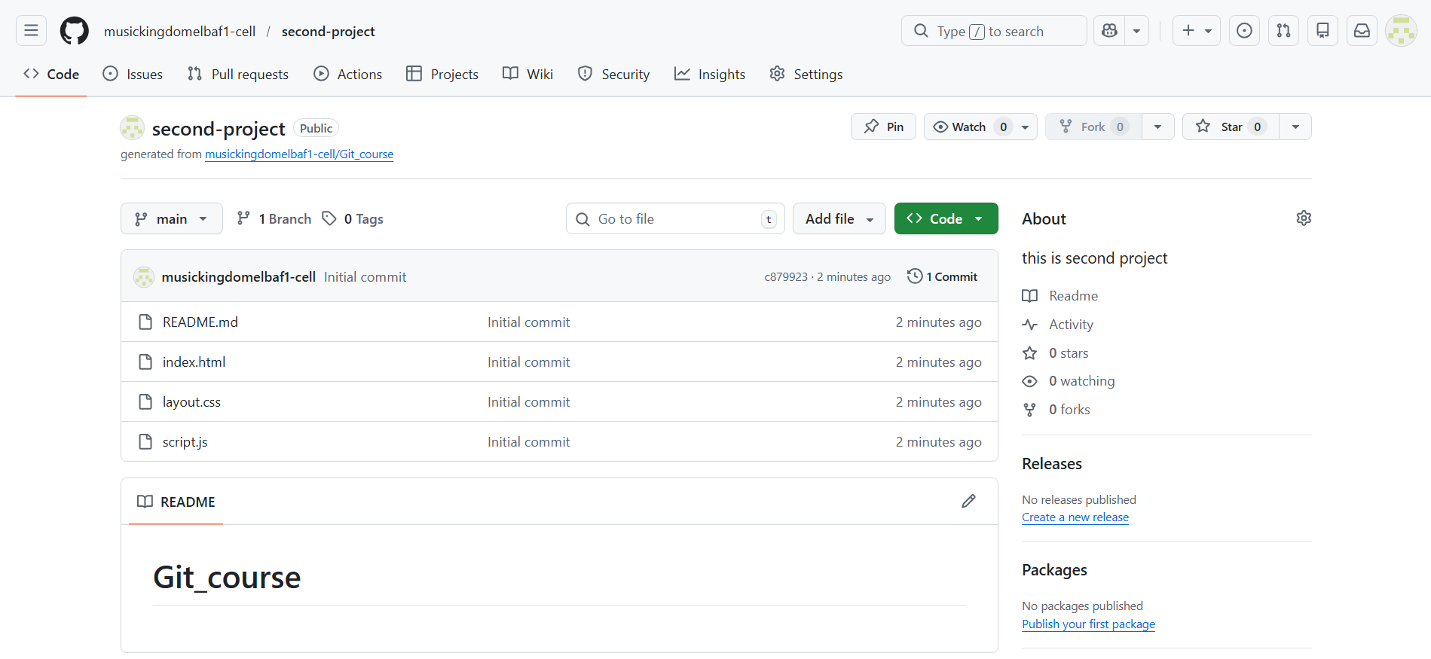

Option 3: Push an existing local repository to github.com

Method 1: Push an Existing Local Repository to GitHub (Interactive)
# Source: ScreenShots Source: Provided by: [Persons Table -> ID Column: 1, Name_En Column: Motasem Essam] -> Tool: [Lightshot Program] -> From [Operating System: Windows] on [3/6/2026]
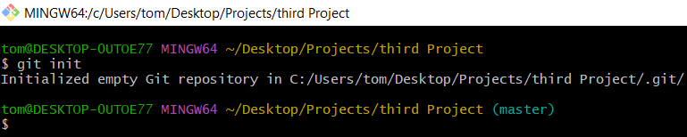
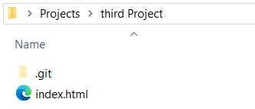
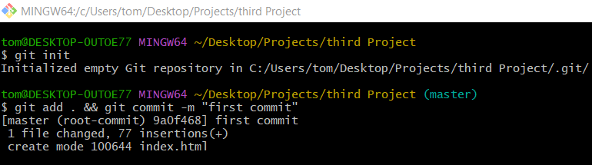
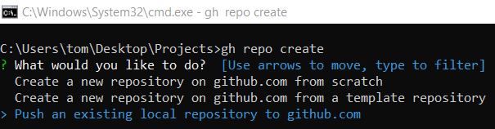
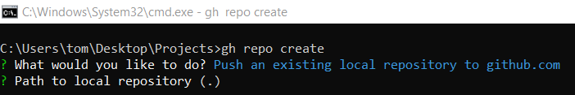
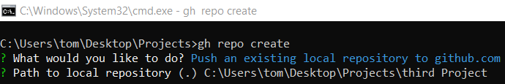
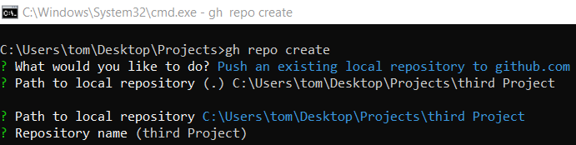
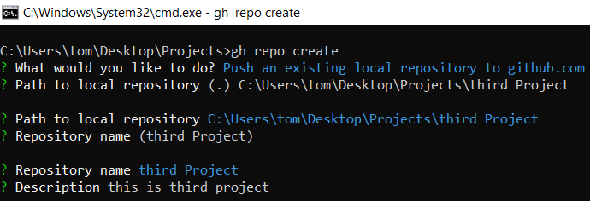
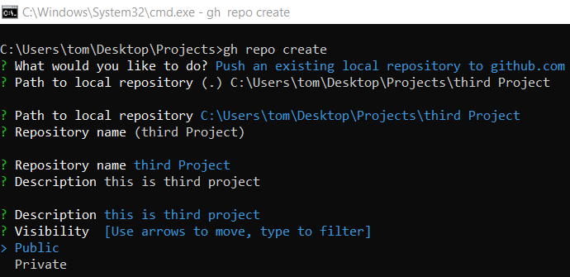
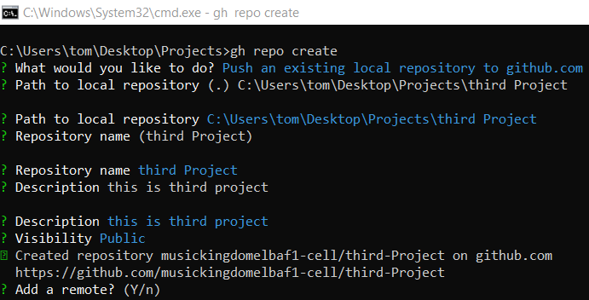
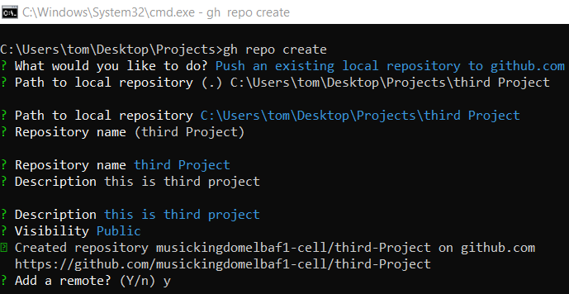
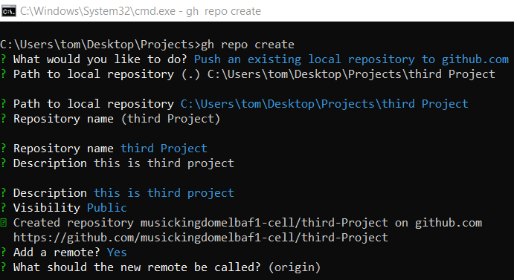
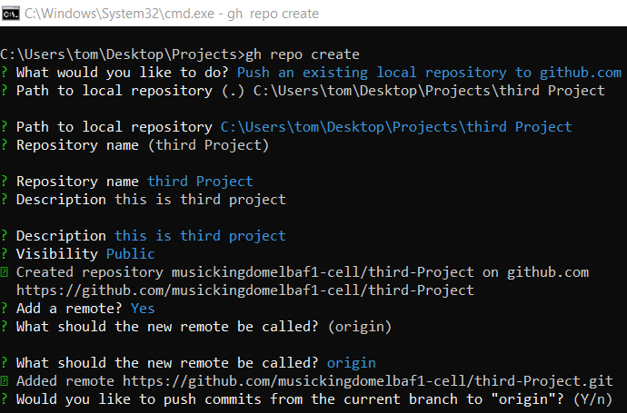
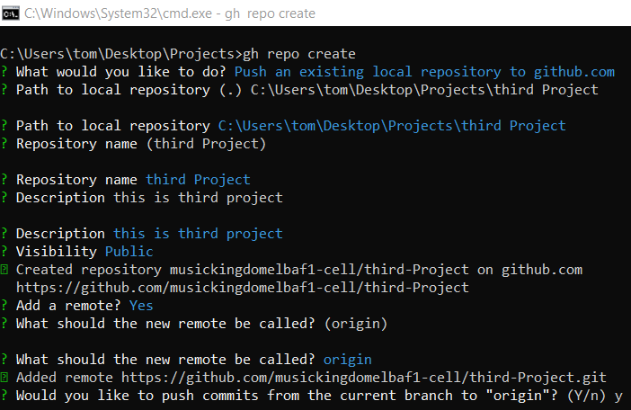
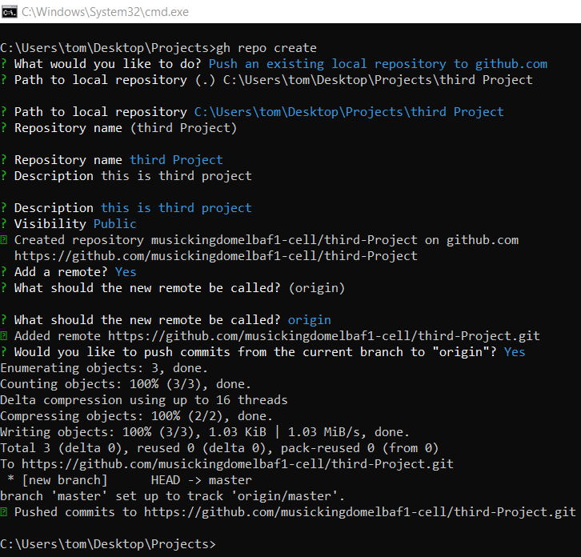

# Source: ScreenShots Source: Provided by: [Persons Table -> ID Column: 1, Name_En Column: Motasem Essam] -> Tool: [Lightshot Program] -> From [Site: https://github.com] on [3/6/2026]
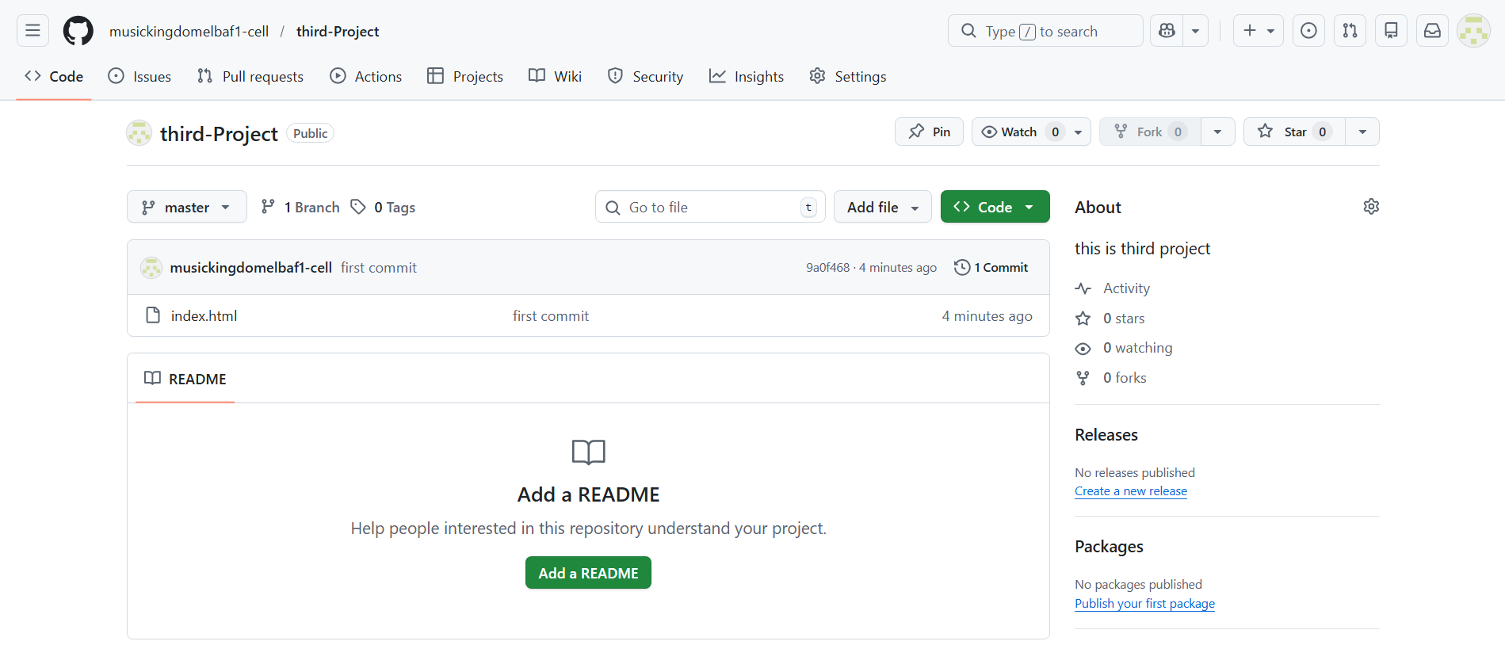

Method 2: Push an Existing Local Repository to GitHub (Direct Command)
# Source: ScreenShots Source: Provided by: [Persons Table -> ID Column: 1, Name_En Column: Motasem Essam] -> Tool: [Lightshot Program] -> From [Operating System: Windows] on [3/6/2026]

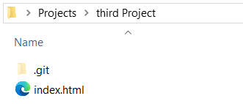

gh repo create third-project --public --source=. --push
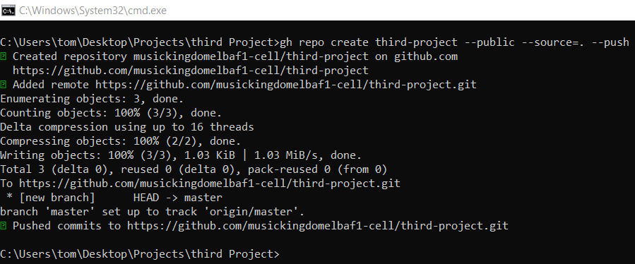

# Source: AI Source: Provided by: [Data Path: Persons Table -> ID Column: 1, Name_En Column: Motasem Essam] -> From: [Chatgpt (GPT‑5 Mini)] on [3/6/2026]
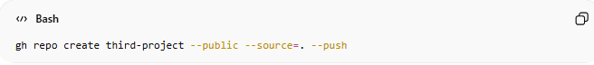
gh repo create third-project --public --source=. --push
- gh repo create → Create a new GitHub repository
- third-project → Repository name
- --public → Make it public
- --source=. → Use current folder as repo
- --push → Upload local files immediately
✅ Creates and pushes your local project to GitHub in one step.

Check if the repo exists (using CLI)
# Source: ScreenShots Source: Provided by: [Persons Table -> ID Column: 1, Name_En Column: Motasem Essam] -> Tool: [Lightshot Program] -> From [Operating System: Windows] on [3/6/2026]
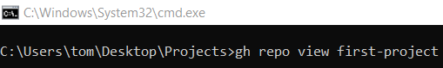
gh repo view first-project
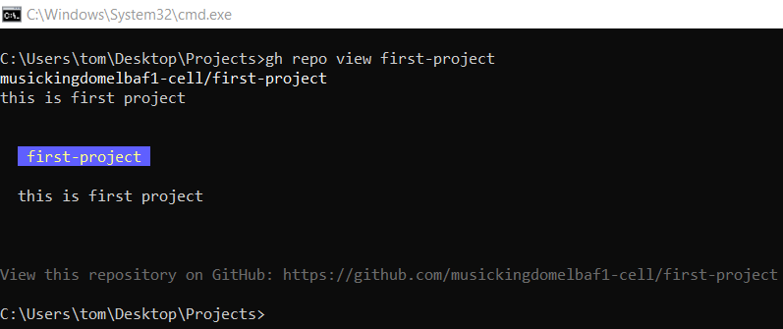

Delete Repository Using GitHub CLI
# Source: ScreenShots Source: Provided by: [Persons Table -> ID Column: 1, Name_En Column: Motasem Essam] -> Tool: [Lightshot Program] -> From [Operating System: Windows] on [3/6/2026]
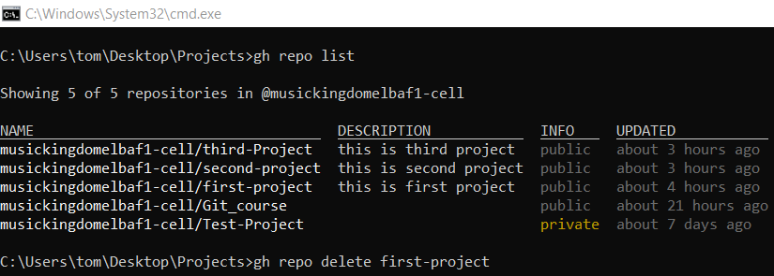
gh repo delete first-project
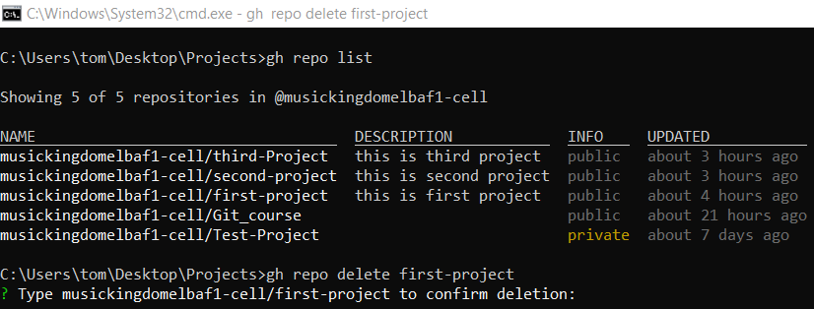
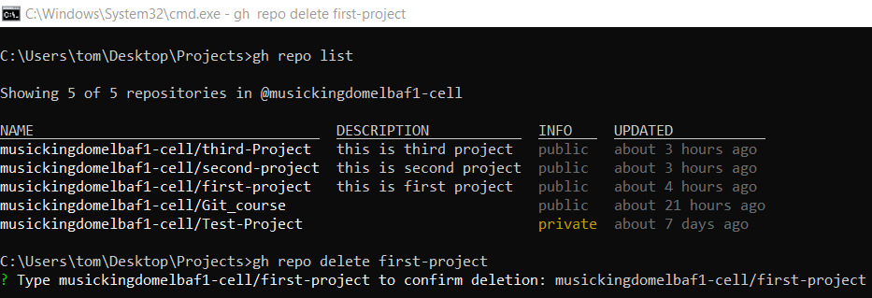
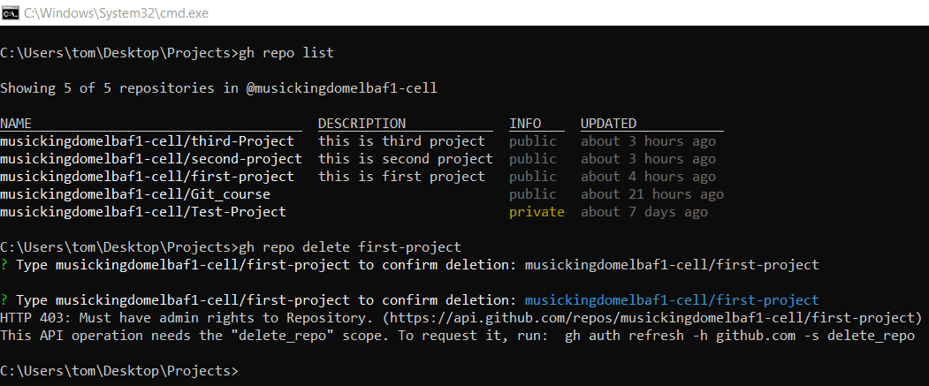
This is admin rights problem solve it by Refresh GitHub CLI Authentication to Delete
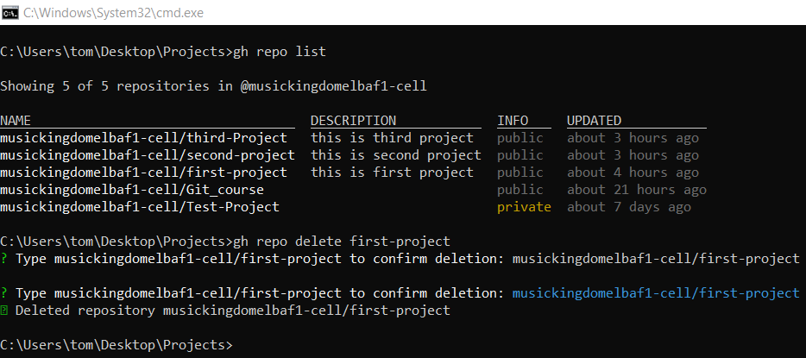
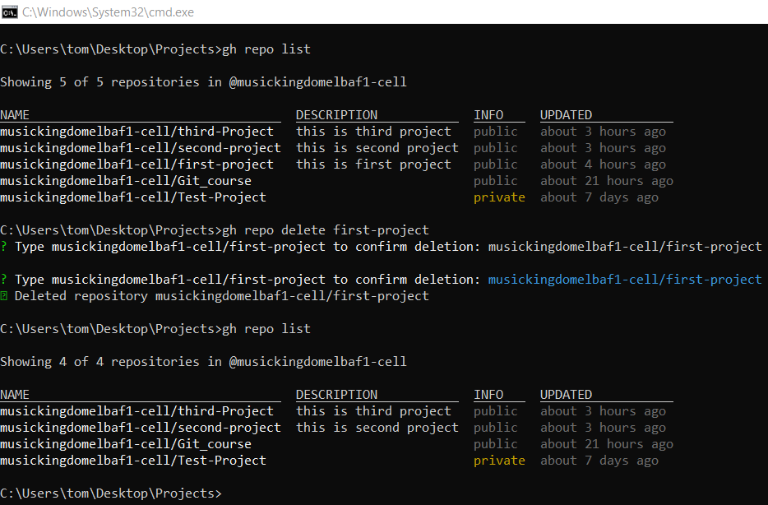

Refresh GitHub CLI Authentication to Delete
# Source: ScreenShots Source: Provided by: [Persons Table -> ID Column: 1, Name_En Column: Motasem Essam] -> Tool: [Lightshot Program] -> From [Operating System: Windows] on [3/6/2026]
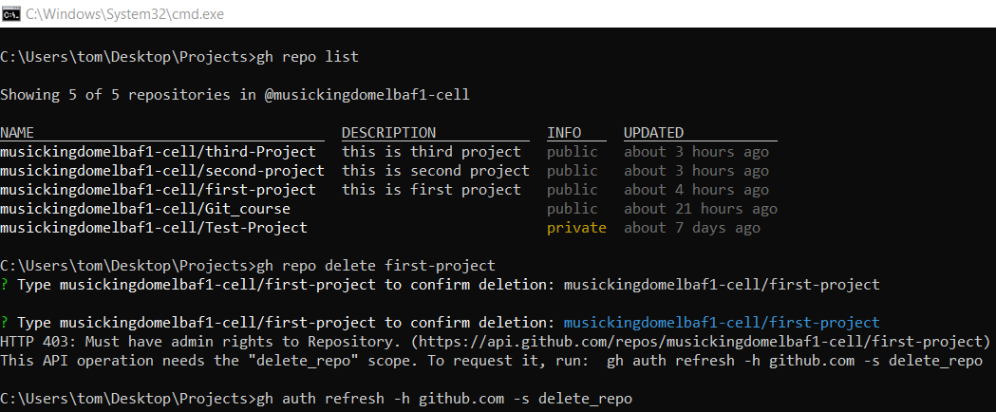
gh auth refresh -h github.com -s delete_repo
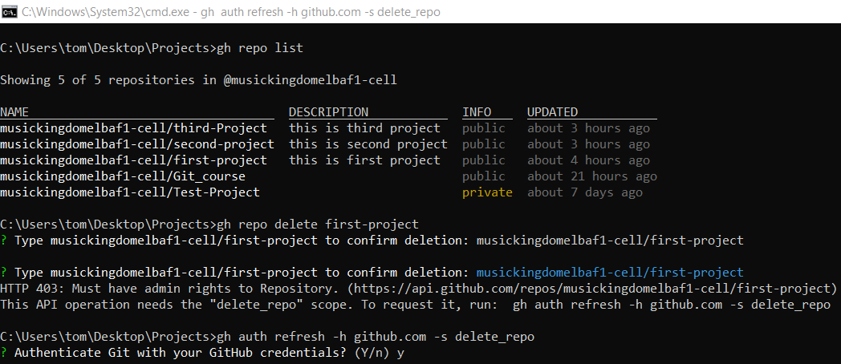
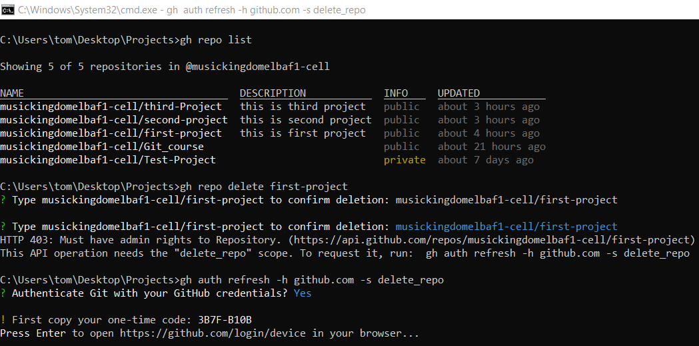
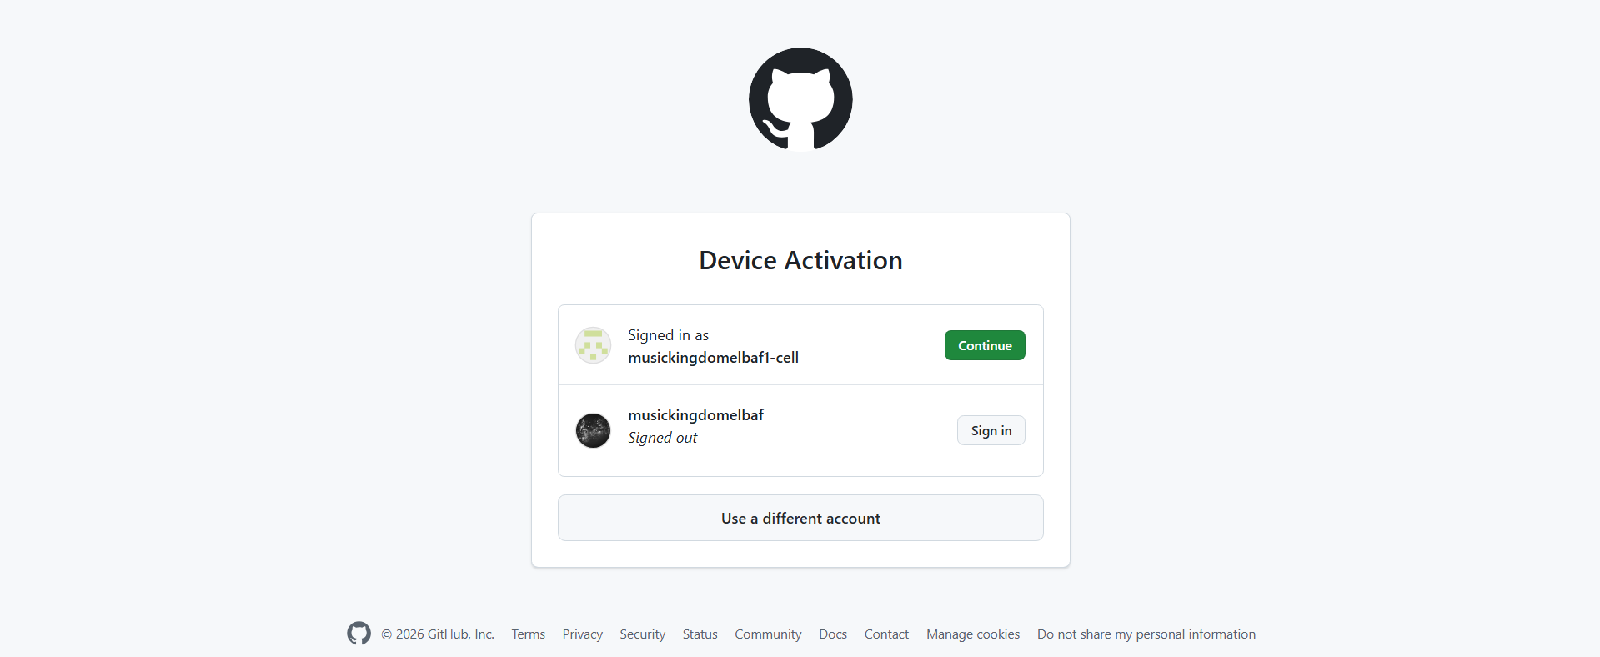
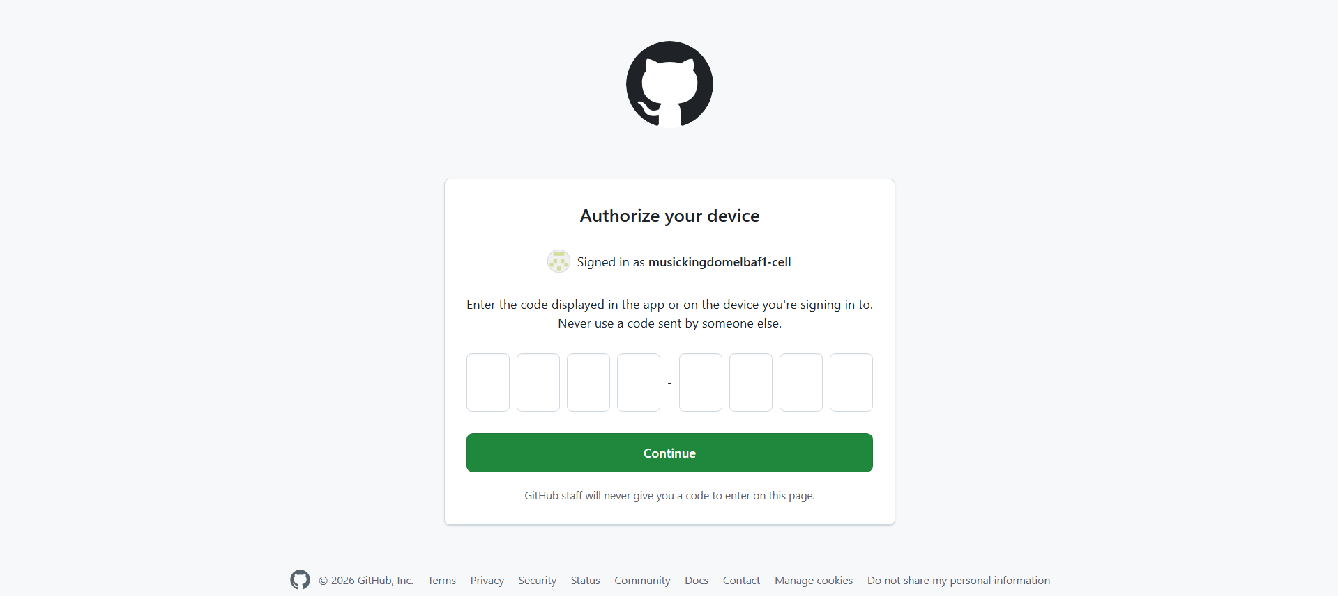
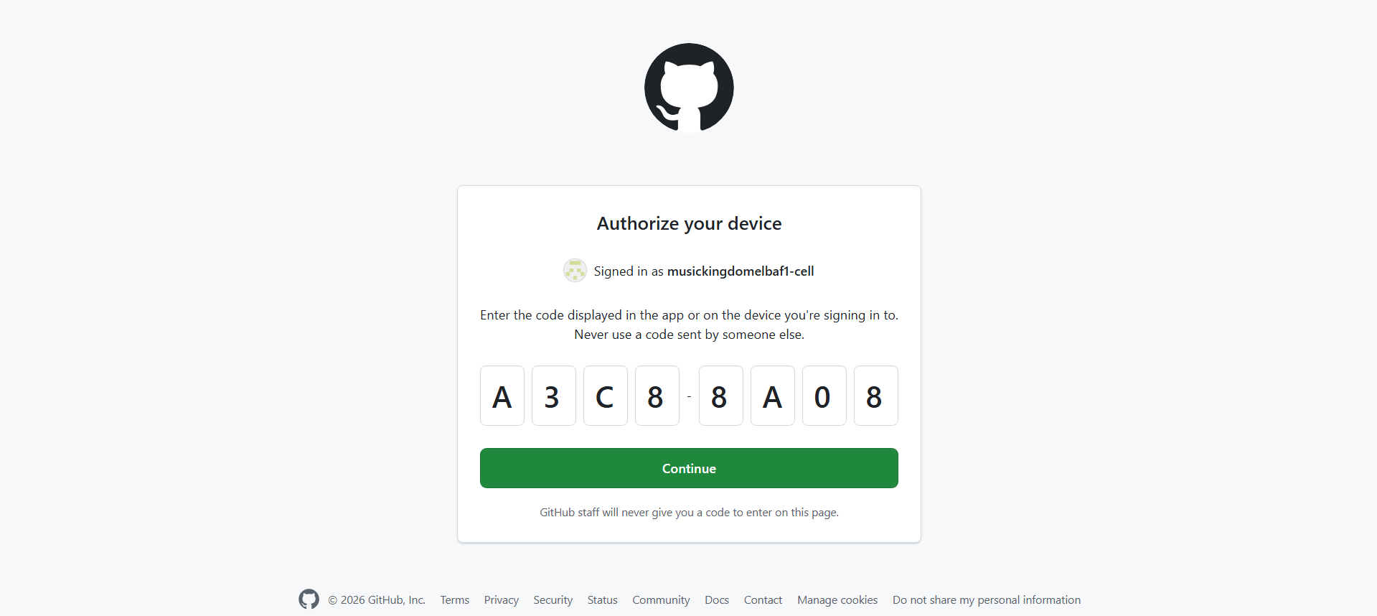
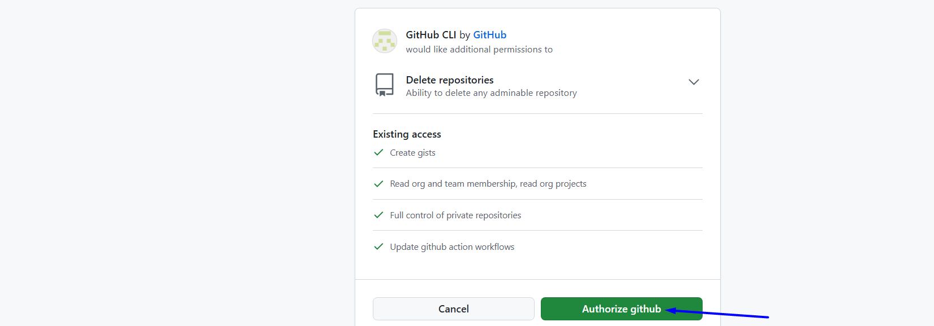
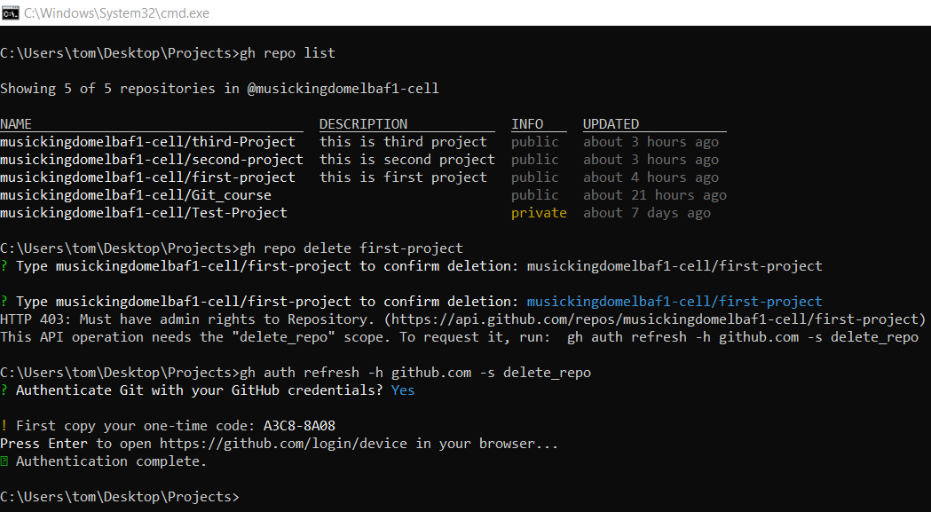

Clone Repository
# Source: ScreenShots Source: Provided by: [Persons Table -> ID Column: 1, Name_En Column: Motasem Essam] -> Tool: [Lightshot Program] -> From [Site: https://github.com] on [3/6/2026]
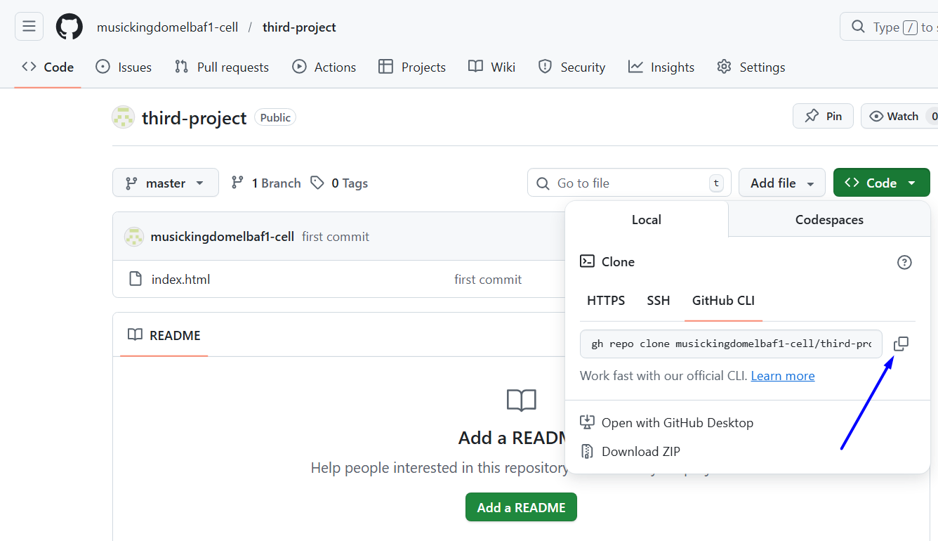
# Source: ScreenShots Source: Provided by: [Persons Table -> ID Column: 1, Name_En Column: Motasem Essam] -> Tool: [Lightshot Program] -> From [Operating System: Windows] on [3/6/2026]
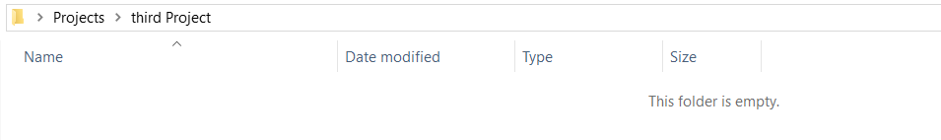
gh repo clone musickingdomelbaf1-cell/third-project
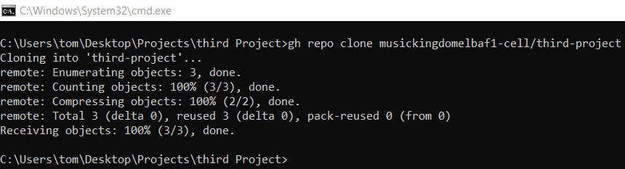

GitHub CLI Stages

1️⃣ (First Time Only) – Login with GitHub CLI
# Source: AI Source: Provided by: [Data Path: Persons Table -> ID Column: 1, Name_En Column: Motasem Essam] -> From: [Chatgpt (GPT‑5 Mini)] on [3/6/2026]
Authenticate your machine with GitHub:
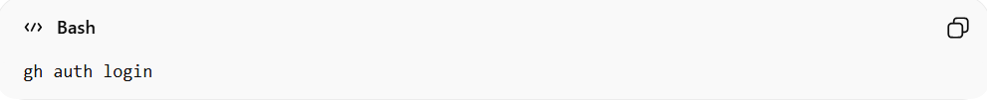
gh auth login
Follow the prompts:
- Choose GitHub.com
- Choose HTTPS or SSH
- Authorize in browser
Now your Git is connected to GitHub securely ✅

2️⃣ Add Changes
# Source: AI Source: Provided by: [Data Path: Persons Table -> ID Column: 1, Name_En Column: Motasem Essam] -> From: [Chatgpt (GPT‑5 Mini)] on [3/6/2026]
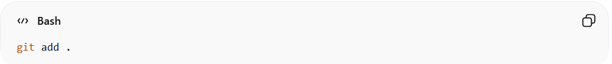
git add .
Or specific file:
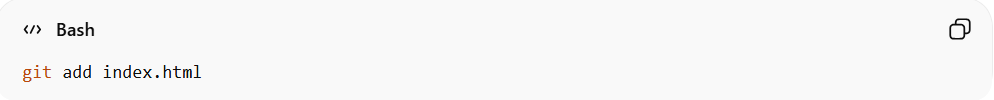
git add index.html

3️⃣ Commit Changes
# Source: AI Source: Provided by: [Data Path: Persons Table -> ID Column: 1, Name_En Column: Motasem Essam] -> From: [Chatgpt (GPT‑5 Mini)] on [3/6/2026]
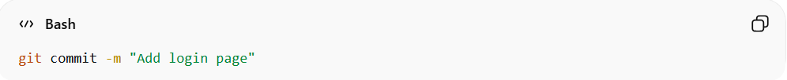
git commit -m "Add login page"

4️⃣ Push to GitHub
# Source: AI Source: Provided by: [Data Path: Persons Table -> ID Column: 1, Name_En Column: Motasem Essam] -> From: [Chatgpt (GPT‑5 Mini)] on [3/6/2026]
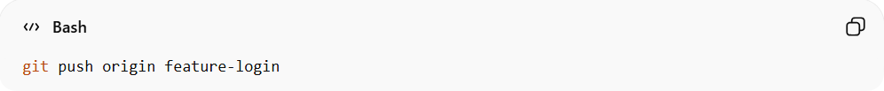
git push origin feature-login
If first time pushing the branch:
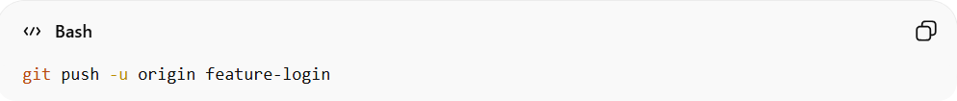
git push -u origin feature-login

5️⃣ Create a Pull Request Using GitHub CLI
# Source: AI Source: Provided by: [Data Path: Persons Table -> ID Column: 1, Name_En Column: Motasem Essam] -> From: [Chatgpt (GPT‑5 Mini)] on [3/6/2026]
After pushing your branch, you can create a PR directly from terminal:
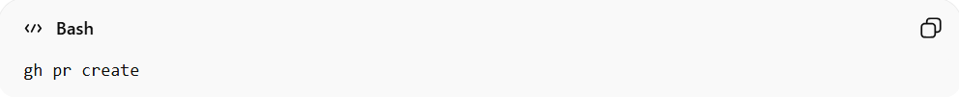
gh pr create
It will ask:
- Base branch (usually main)
- Title
- Description
Or do it directly:
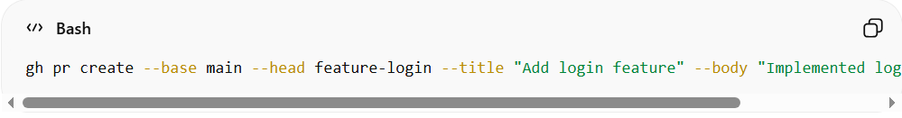
gh pr create --base main --head feature-login --title "Add login feature" --body "Implemented login functionality"
breakdown:
- gh → GitHub CLI
- pr create → Create a Pull Request
- --base main → Merge into main (target branch)
- --head feature-login → Merge from feature-login (source branch)
- --title → Pull Request title
- --body → Pull Request description

🔁 Full Workflow Example
# Source: AI Source: Provided by: [Data Path: Persons Table -> ID Column: 1, Name_En Column: Motasem Essam] -> From: [Chatgpt (GPT‑5 Mini)] on [3/6/2026]
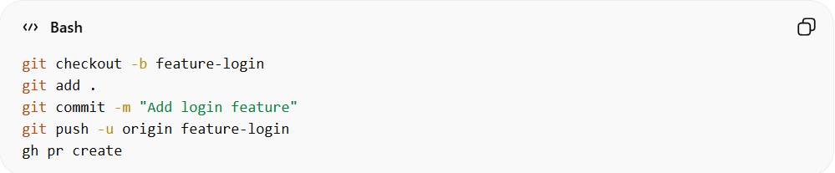
git checkout -b feature-login
git add .
git commit -m "Add login feature"
git push -u origin feature-login
gh pr create

🧠 What gh Actually Does
# Source: AI Source: Provided by: [Data Path: Persons Table -> ID Column: 1, Name_En Column: Motasem Essam] -> From: [Chatgpt (GPT‑5 Mini)] on [3/6/2026]
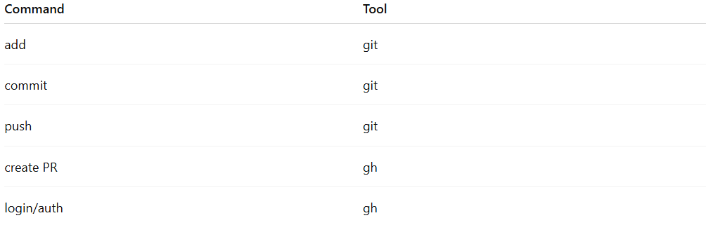
Command | Tool
add | git
commit | git
push | git
create PR | gh
login/auth | gh

So remember:
git = version control
gh = GitHub platform interaction

Example

1️⃣ (First Time Only) – Login with GitHub CLI
# Source: ScreenShots Source: Provided by: [Persons Table -> ID Column: 1, Name_En Column: Motasem Essam] -> Tool: [Lightshot Program] -> From [Operating System: Windows] on [3/6/2026]
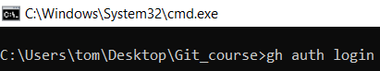
gh auth login
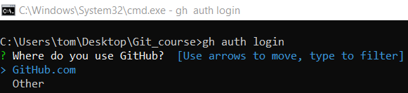
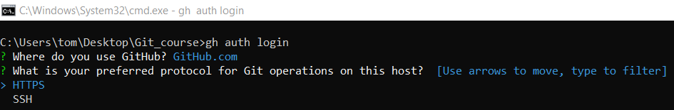
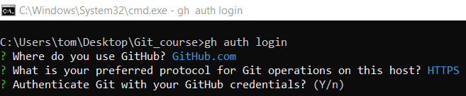
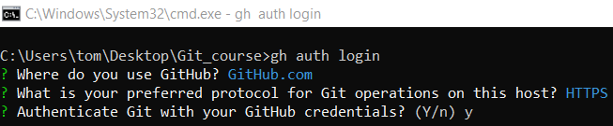
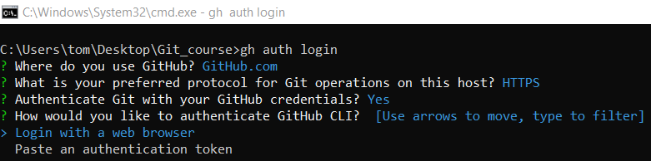
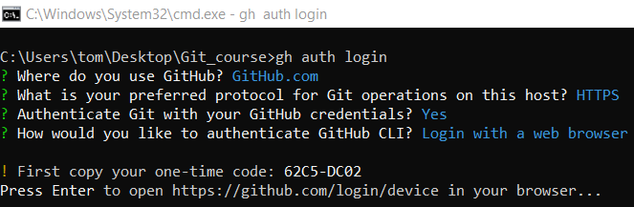
# Source: ScreenShots Source: Provided by: [Persons Table -> ID Column: 1, Name_En Column: Motasem Essam] -> Tool: [Lightshot Program] -> From [Site: https://github.com] on [3/6/2026]
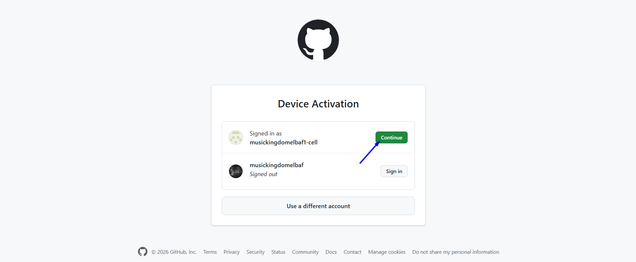
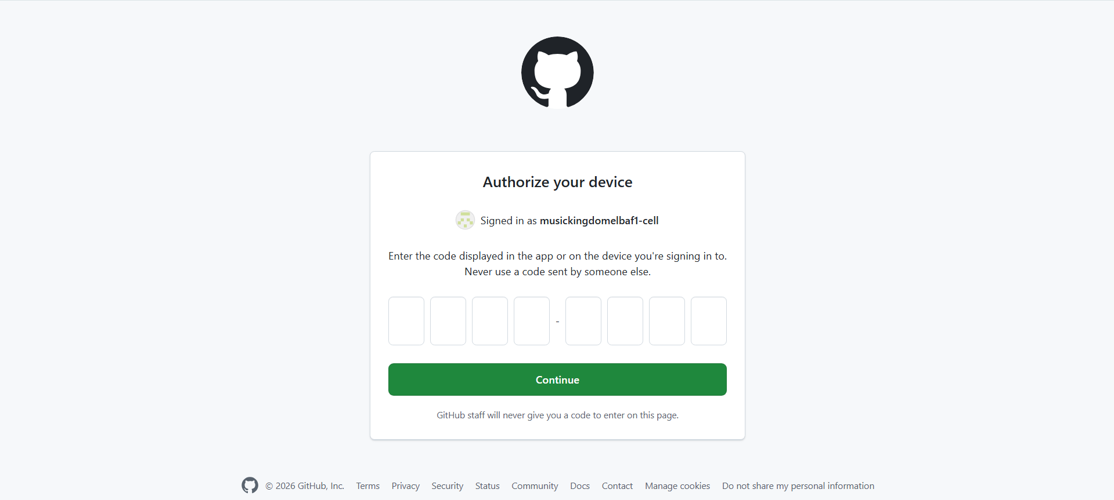
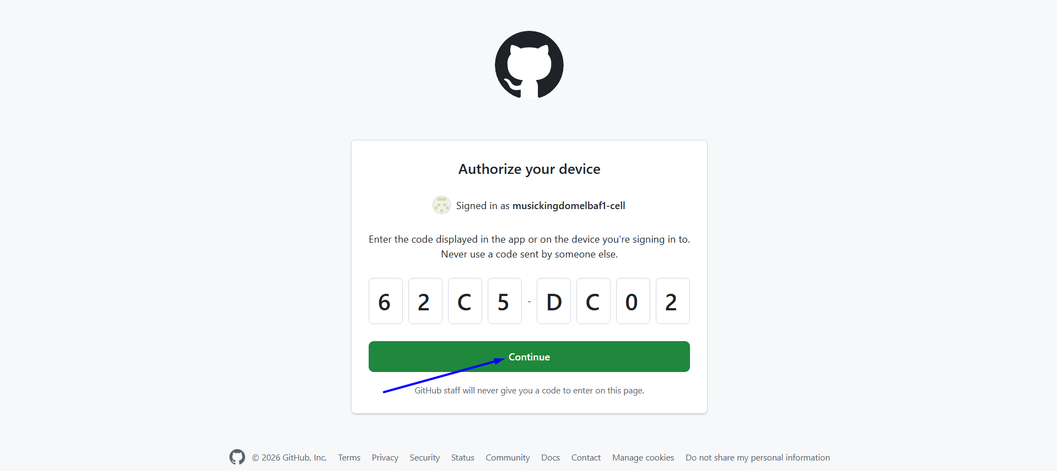
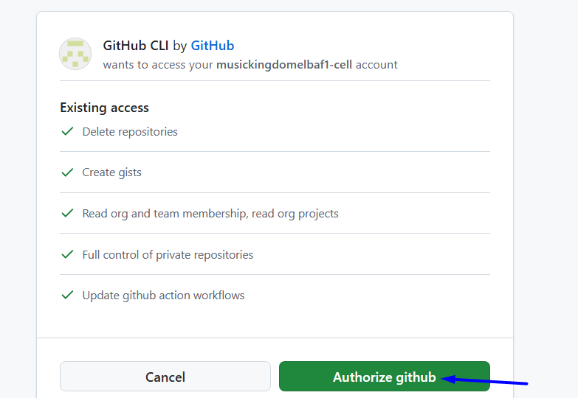

# Source: ScreenShots Source: Provided by: [Persons Table -> ID Column: 1, Name_En Column: Motasem Essam] -> Tool: [Lightshot Program] -> From [Operating System: Windows] on [3/6/2026]
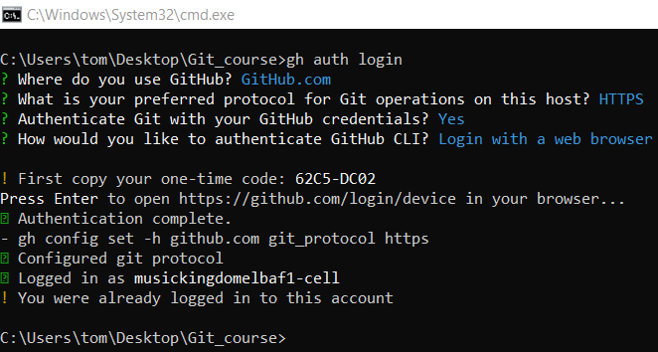

2️⃣ Add Changes
# Source: ScreenShots Source: Provided by: [Persons Table -> ID Column: 1, Name_En Column: Motasem Essam] -> Tool: [Lightshot Program] -> From [Operating System: Windows] on [3/6/2026]
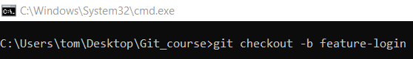
git checkout -b feature-login
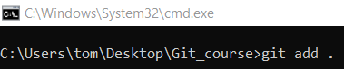
git add .

3️⃣ Commit Changes
# Source: ScreenShots Source: Provided by: [Persons Table -> ID Column: 1, Name_En Column: Motasem Essam] -> Tool: [Lightshot Program] -> From [Operating System: Windows] on [3/6/2026]
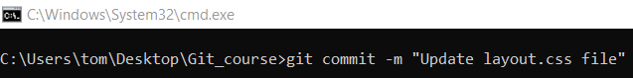
git commit -m "Update layout.css file"
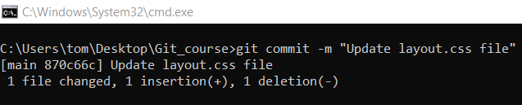

4️⃣ Push to GitHub
# Source: ScreenShots Source: Provided by: [Persons Table -> ID Column: 1, Name_En Column: Motasem Essam] -> Tool: [Lightshot Program] -> From [Operating System: Windows] on [3/6/2026]
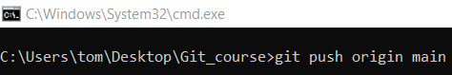
git push origin main
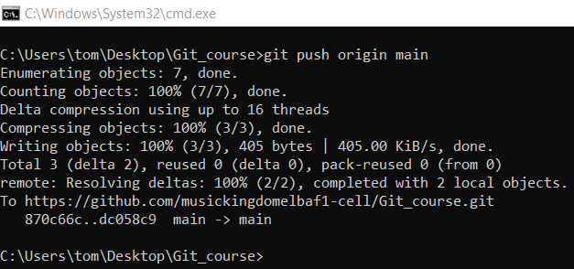

5️⃣ Create a Pull Request Using GitHub CLI
# Source: ScreenShots Source: Provided by: [Persons Table -> ID Column: 1, Name_En Column: Motasem Essam] -> Tool: [Lightshot Program] -> From [Operating System: Windows] on [3/6/2026]
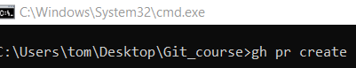
gh pr create
